Web-Based Subscription Delivery System with Route Optimization
Project Members
- G.Pramodh – 23MCCE26
- D.Sai Kumar - 23MCCE24
Problem Statement
To design a web-based subscription delivery system that optimally assigns and routes delivery partners from a single depot to multiple customers within fixed time slots using clustering and routing algorithms.
Project Description
The system is a web-based subscription delivery platform for fruit bowls where customers can register, choose subscription plans, customize orders, and select fixed morning or evening delivery slots. All deliveries start from a single pickup location. Customers can pause, resume, or skip deliveries before a defined cut-off time, after which orders are locked. The system automatically assigns orders to delivery partners and generates optimized delivery routes using clustering and routing algorithms. Each partner collects all items from the depot, delivers to multiple customers within the time slot, and returns to the depot. The platform provides separate dashboards for admins, delivery partners, and customers, and is designed to be secure, scalable, and reliable.
Actors
- Admin
- Customer
- Delivery Partner
System Architecture
- Web-based application
- Centralized backend
- Role-based access control
- Database-driven scheduling
- Static optimization algorithms
Overall Workflow
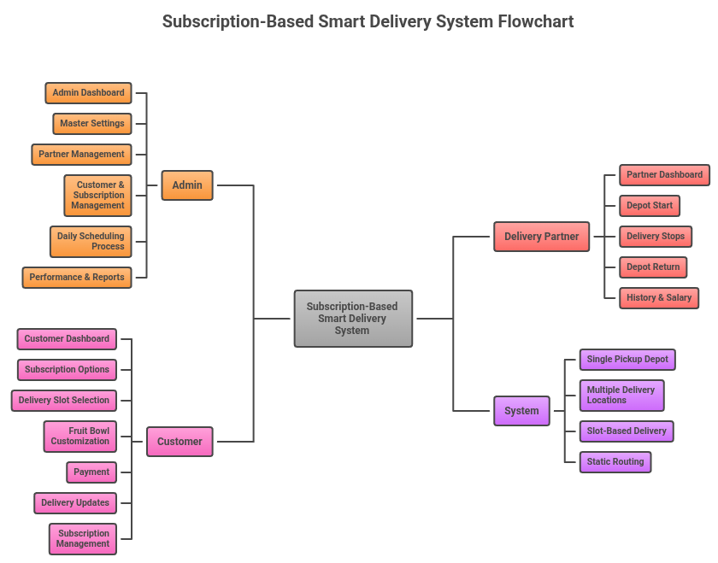
Authentication & Role Management
Pre-condition :-- User not logged in
Process :-- Login → Role identification → Session/JWT generation → Dashboard redirection
Output Sec :-- ure login and role-based dashboard access

Customer Registration & Subscription Management
Pre-condition :-- New customer or new subscription
Process :-- Enter personal and delivery details → Choose subscription plan and delivery slot → Customize fruit bowl → Complete payment
Output :-- Customer account created, subscription activated, orders scheduled.

Order Generation and Cutoff Managment
Pre-condition :-- Active subscriptions exist and cut-off time not reached
Process :-- Daily order generation → Apply pause/skip rules → Group orders by delivery slot → Lock orders after cut-off
Output :-- Finalized orders ready for scheduling with no further modifications

Delivery Partner Management
Pre-condition :-- Admin logged in
Process :-- Add or remove delivery partners → Set partner availability per slot → Activate or deactivate accounts
Output :-- Updated partner availability stored

Delivery Scheduling & Customer Clustering
Pre-condition :-- Orders locked and delivery partners available
Process :-- Fetch customer locations → Apply K-Means clustering → Assign each cluster to a delivery partner
Output :-- Balanced customer clusters created per partner

Route Optimization
Pre-condition :-- Customer clusters available
Process :-- Start route from depot → Apply Nearest Neighbor TSP → Optimize delivery sequence → Calculate route time
Output :-- Optimized delivery routes generated

Schedule Validation & Admin Approval
Pre-condition :-- Routes generated
Process :-- Validate route duration against slot time → Flag overloaded routes → Admin approval or manual override
Output :-- Final delivery schedules locked for execution

Delivery Execution
Pre-condition :-- Schedule approved and delivery slot started
Process :-- Delivery partner views assigned route → Delivers orders in sequence → Marks deliveries as completed
Output :-- Orders marked as delivered and logs recorded

Salary & Earnings Calculation
Pre-condition :-- Delivery completion data available
Process :-- Count completed deliveries → Calculate monthly salary → Apply bonuses or penalties
Output :-- Earnings updated and salary reports generated

Admin Monitoring & Reporting
Pre-condition :-- Admin logged in
Process :-- Aggregate delivery, revenue, and partner performance data → Generate reports
Output :-- Dashboards and downloadable reports available

Assumptions
- Single depot location
- Static travel conditions
- Fixed delivery slots
- Fixed delivery time per stop

